|  |  |
| --- | --- |
| **Ex. 3** | **EXPLORING CONDITIONAL STATEMENTS** |
| **Date: 5 – Feb - 2024** | |
|  | |

**Aim:**

To explore the use of conditional statements in Python by writing programs for the following and executing them:

1. Create a simple calculator that accepts two numbers and an arithmetic operator as inputs and performs the appropriate operation on the given numbers and displays the result.
2. Get a year from the user and check if it is a leap year and display the result.
3. Find the maximum of three numbers, obtained from the user, using conditional statements.
4. Obtain the marks secured by a student in Maths, Physics, Chemistry, Computer Science, and English, out of 100, and calculate their average. Check the range within which the average mark falls and display the appropriate grade. (A+ grade - 90 to 100, A grade - 80 to 90, B+ grade - 70 to 80, B grade - 60 to 70, C grade - 50 to 60, D grade - 40 to 50, F grade - less than 40)
5. identify if a point (x,y) lies inside, outside, or on the circumference of a circle of radius "r", centered at the origin. Obtain the values of x, y, and r from the user.
6. Obtain the lengths of the 4 sides of a quadrilateral and the angles at each corner of the quadrilateral. Verify if the dimensions represent a valid quadrilateral and if so, check whether the dimensions represent a square, a rectangle, or neither.

**Algorithm:**

**(a)**

Step 1: Get Inputs for the arithmetic Operands and the Operation

Step 2: Using Conditional Statements Operate the Operands

Step 3: Print the result To the user

**(b)**

Step 1: Get the year from the user

Step 2: Using Conditional Statements check if the year is a leap year

Step 3: Print the result to the user

**(c)**

Step 1: Get the 3 numbers from the user

Step 2: Figure out which number is larger

Step 3: Print that the number is larger than the others

**(d)**

Step 1: Get the marks of 5 subjects from the user

Step 2: Find the average and the corresponding category Grade

Step 3: Display the grade of the user

**(e)**

Step 1: Get the radius and euclidean points from the user

Step 2: Check the euclidean distance of the point from the centre and compare it with the radius of the circle

Step 3: Display the relative position to the user

**(f)**

Step 1: Take inputs of the side length and angles of the shape form the user

Step 2: - validate if the shape is a quadrilateral

- Square if number of unique lengths of sides is 1 and all angles = 90

- Rectagle if number of unique length of sides is 2 and all angles = 90

Step 3: Display the shape to the user

**Program:**

**(a)**

opt = 1

while True:

a = input("Enter Operand a : ")

b = input("Enter Operand b : ")

c = input("Arithmetic Operation (+ , - , * , /) : ")

if(c=="+"):

print(a,c,b , " = " ,a+b)

elif(c=="-"):

print(a,c,b , " = " ,a-b)

elif(c=="*"):

print(a,c,b , " = " ,a*b)

else:

print(a,c,b," = ",a/b)

opt= int(input("Enter (1) if you want to continue : "))

if opt!=1:

break

**(b)**

year = int(input("Enter the year : "))

print("Leap Year : ",end="")

if((year%4 ==0 or year%400==0) and not year%100==0):

print("True")

else:

print("false")

**(c)**

a,b,c = int(input("Enter the first Number : ")),int(input("Enter the second Number : ")),int(input("Enter the third Number : "))

if(a>b and a>c) : print("First Number ({}) is greater".format(a))

if(b>a and b>c) : print("Second Number ({}) is greater".format(b))

if(c>a and c>b) : print("Third Number ({}) is greater".format(c))

**(d)**

marks = [int(input("Enter Mark for Maths :")),int(input("Enter Mark for Physics :")),int(input("Enter Mark for Chemistry :")),int(input("Enter Mark for Computer Science :")),int(input("Enter Mark for English :"))]

averagemarks = 0

for i in marks:

averagemarks+=i

averagemarks/=5

if(averagemarks >90):

print("Grade : A+")

elif(averagemarks >80):

print("Grade : A")

elif(averagemarks >70):

print("Grade : B+")

elif(averagemarks >60):

print("Grade : B")

elif(averagemarks >50):

print("Grade : C")

elif(averagemarks >40):

print("Grade : D")

else:

print("Grade : F")

**(e)**

r = float(input("Enter the Radius of the circle : "))

x,y = eval("[" + input("Enter the x and y coordinates seperated by comman ( x,y ) : ")+ "]")

if((x**2 + y**2)**(1/2) > r):

print("Outside the circle")

elif((x**2 + y**2)**(1/2) < r):

print("Inside the circle")

else:

print("On the Circumference of the circle")

**(f)**

SideLengths = [float(input("Enter the length of side - {} : ".format(i))) for i in range(1,5)]

Angles = [float(input("Enter the degree of angle - {} : ".format(i))) for i in range(1,5)]

var = 0

for i in Angles:

var+=i

if var== 360:

if len(set(Angles))==1:

if set(SideLengths)==1: print("The given Quadrilateral is a Square")

if set(SideLengths)==2: print("The given Quadrilateral is a Rectangle")

else:

print("The Given Dimensions is for a Quadrilateral\nBut does not reperesent a Square or a Rectangle")

else:

print("The Given Dimensions is not valud for a Quadrilateral")

**Screenshot of Output:**

**(a)**

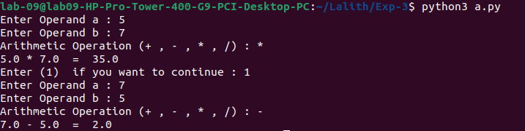

**(b)**

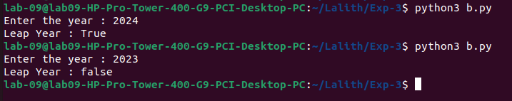

**(c)**

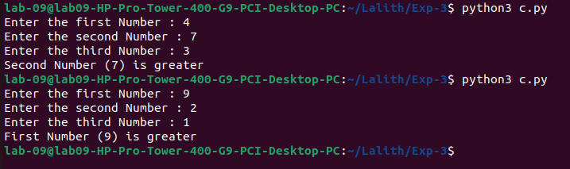**(d)**

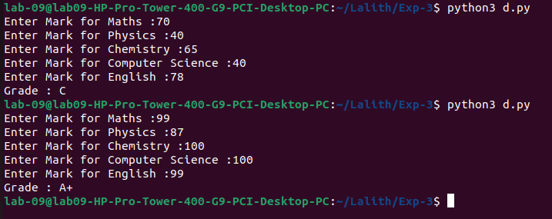

**(e)**

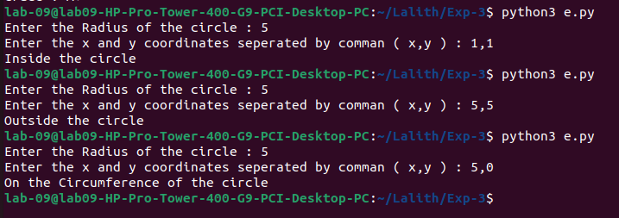**(f)**

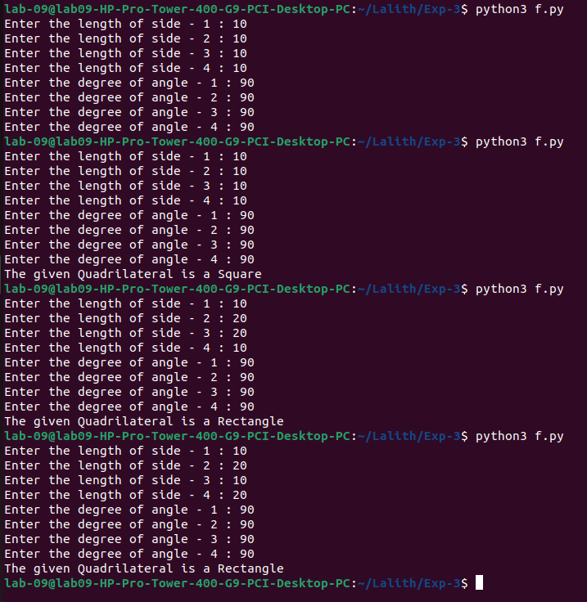

**Result:**

Thus, programs have been written and executed to explore the use of conditional statements in Python.